enMotion® Recessed Dispenser Product Code 59472

DC To AC Conversion Instructions

Kit includes (1) each:

AC to DC Switching Supply

Battery Box Power Adapter

Split Wire Bushing

Push Mountable Cable Tie

AC to DC Switching Supply

The switching power supply in the kit is UL listed, double insulated, and equipped with a standard 2 pole NEMA plug intended for mounting into a standard 120V NEMA duplex outlet. The power supply is equipped with a 9’ (3m) low voltage outlet cord terminated with a polarized connector for attachment with a mating connector of the Battery Box Power Adapter.

For warranty purposes, it is required that the power supply must plug into an A/C outlet that is not accessible to the dispenser user. The A/C outlet is usually installed above a dropped ceiling found in most commercial bathroom facilities. If not available, consult a licensed electrical contractor.

The power supply output cord is intended to route through the mounting wall of the dispenser. This is a low voltage, energy limited circuit, similar to those used for thermostats, telephones, security systems, or doorbells. In these applications, there is no requirement for an electrical box or strain relief where the wire exits the wall.

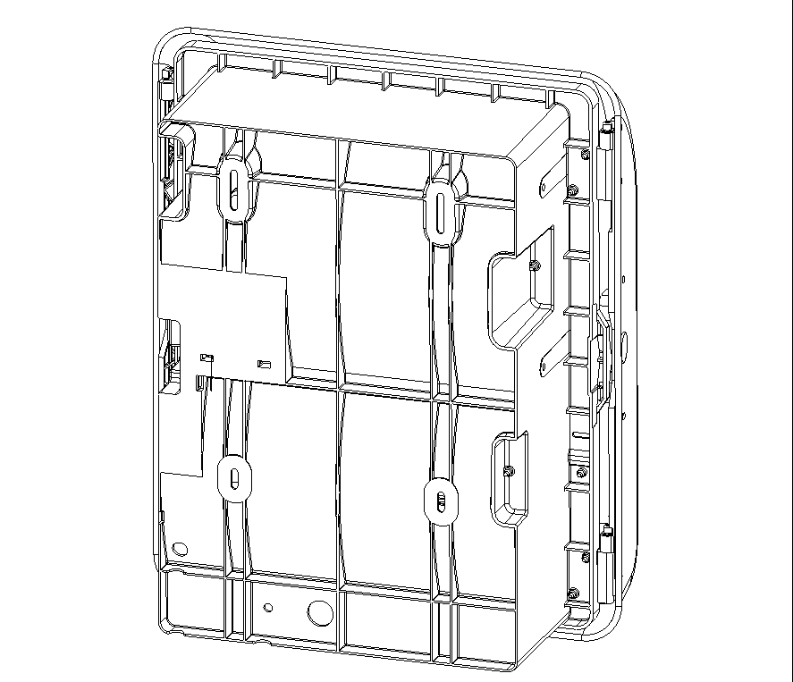
Use only the power supply provided with this kit. Any substitution will void the warranty.

INSTRUCTIONS
- Using the mounting instructions supplied with dispenser, provide opening in wall to accept plastic rear portion of the housing.
- On rear of housing, locate the access hole (shown in diagram). If not present, drill a ¾” and ¼” diameter hole through the rear-housing wall in the general location shown.
- Plug power supply into A/C receptacle located above dropped ceiling. Open a minimum 1” access hole in wall above the ceiling level and feed outlet power supply cord down the inside of the wall to the opening created in step 1 for the recessed dispenser.
- Feed the plug of the outlet power supply cord and approximately 9” of the cord through the large access hole into the dispenser. Open the battery box cover inside the dispenser and pull the power supply outlet plug into the battery box compartment. A long nose plier may be required.
- Position split wire bushing over the power supply outlet cord at the rear of the dispenser and insert the bushing into the hole, snap in place. Insert mounting end of cable tie into the small hole in rear of the dispenser and secure the outlet cord tightly with the cable tie. Snip off excess length of the cable tie. To avoid damage to the cord, route wire through wire slot just below cable tie location.
- Finish mounting the RED dispenser per the installation instructions.
- Install Battery Box Adapter with its contacts oriented to the right side of the battery box.
- Connect output cord plug to mating, polarized receptacle on the Battery Box Adapter. Feed excess power supply cable back into the area under the battery box compartment.
Access Hole &
Cable Tie Mounting Hole
Location
- Close the battery box cover.
- Test power connection by pressing the manual feed button on the dispenser.
- Finish dispenser set up per the installation instructions.

Note: Power at the dispenser can be disconnected either by pulling the Battery Box Adapter out of the battery box or by separating the outlet power cord plug from the Battery Box Adapter receptacle.

